Action Level Formatter
User Guide
By Terrance Mount

The purpose of this guide is to help a user add an action level to a SGS style worksheet in excel. This guide will take you through the steps of downloading an SGS sheet from Engage, adding an action level and then formatting off that action level.
Please follow these steps:
- Download a SGS Lab results from the Engage website.
  - Click the exclamation icon to have “Move Qualifier to Separate Column”. (red arrow)

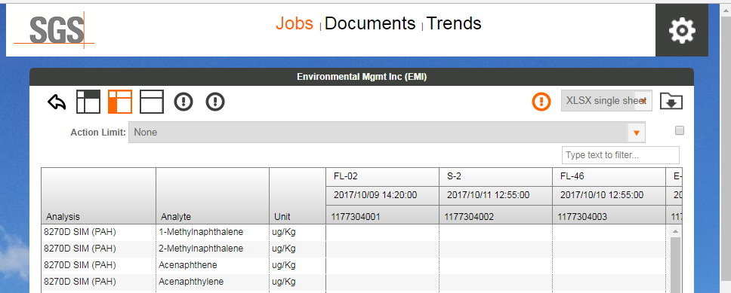
  - Please select the “Sample Crosstab” Icon (green arrow).
  - Click the download file icon (blue arrow).
- Find the Sample Crosstab.xlsx in your downloads folder and open it.
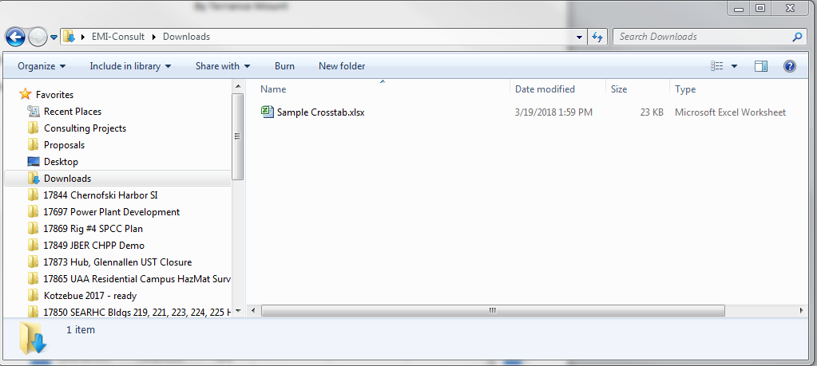

- Delete the notes at the bottom of the sheet.
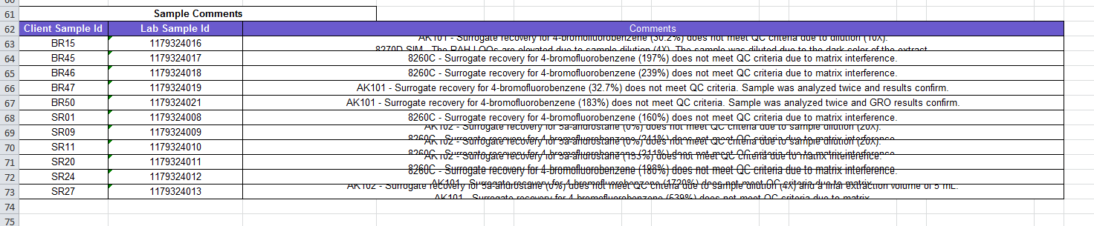
- Add a Column where you want the Action Level and label the heading Action Level
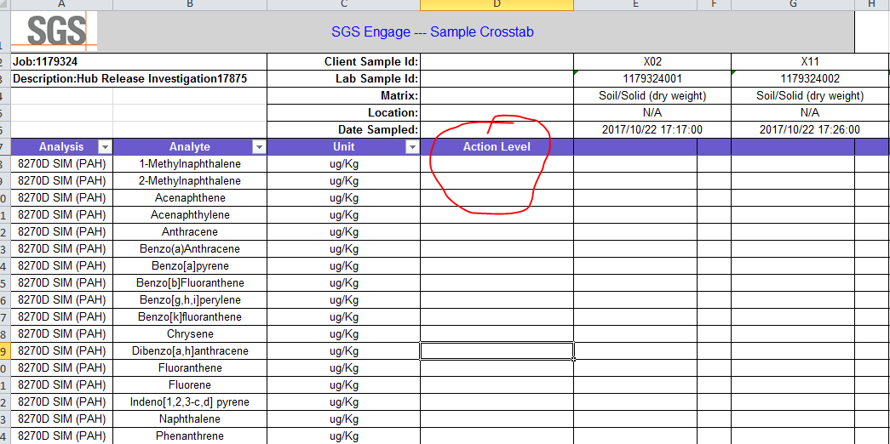
- Open the Action Level Macro on the server (or on your desktop).
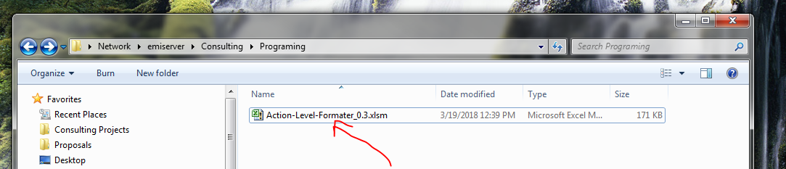
  - It should switch to your already open sample crosstab.xlsx

- Select which Action Level you want. (A)
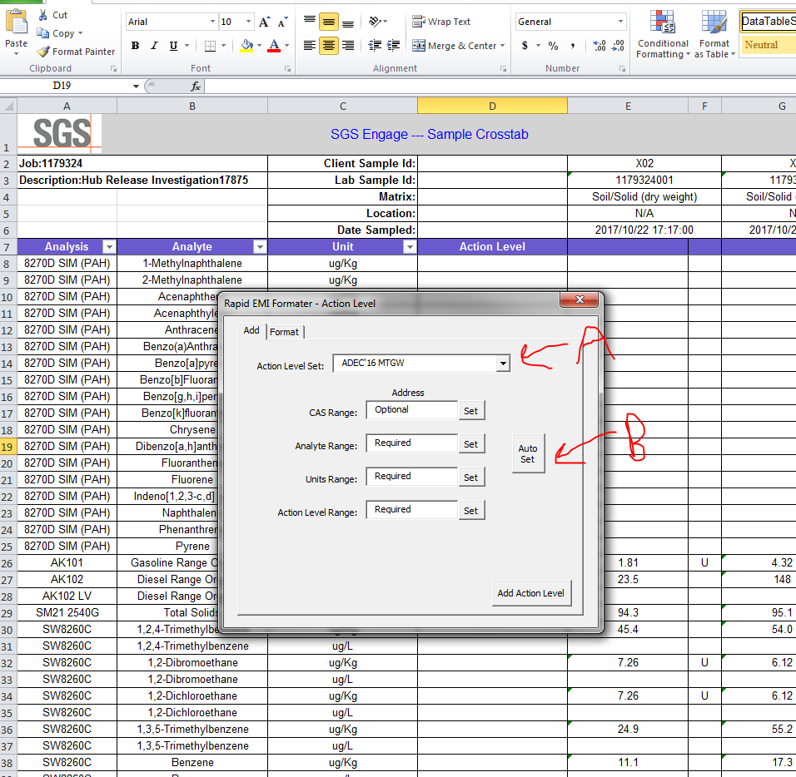
- Click Auto Set (B) or you can individually set the ranges by clicking each of the set buttons.
  - Make sure to check if the columns are correct for the Analyte, Units and Action level.
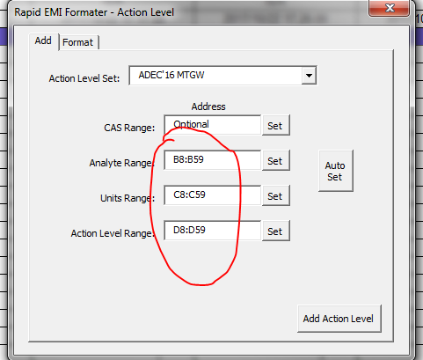
  - B8:B59 means cell B8 to cell B59. The header is not selected. If the comment section was not deleted in step three then it will also select that section too. (Hurts Auto Detection)
- Once everything looks to be in order, click Add Action Level Button.
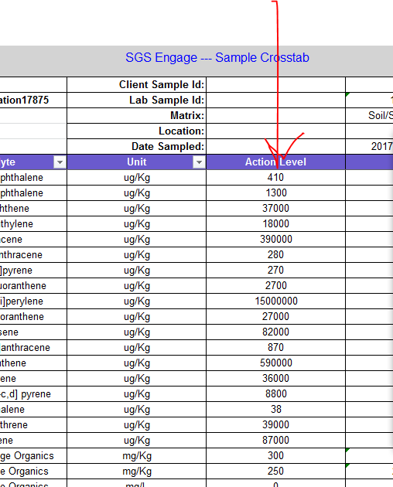
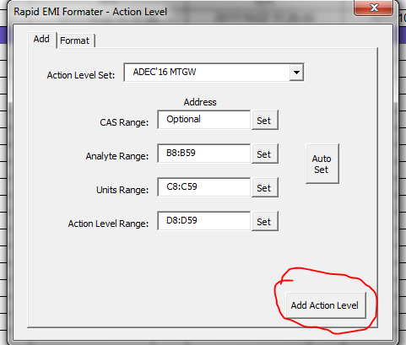
- Check the results.

- Switch to the Format tab.

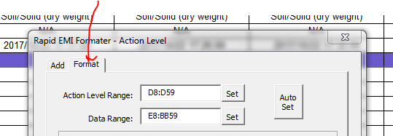

- If the ranges for action level are blank then click the auto set button. Or click on each of the set buttons to set the range manually. (Note these should be filled in if you used the auto set feature on the last tab).
- Now set up the formats you want. First specify the Qualifier to be used (note the qualifiers are in spate columns from Engage).
  - * is a special qualifier that stands for anything. Case 1 will be applied first. If qualifier is not found then it moves to case 2.

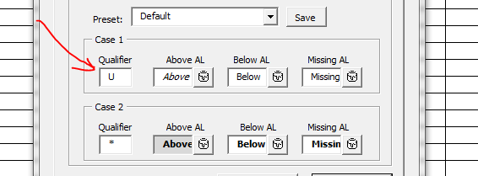
- You have three options: above for when the sample is above the action level, below for when it is equal to or below, or missing for if there is no action level in the corresponding column.
  - Click the paint can by each one to set the format for each.
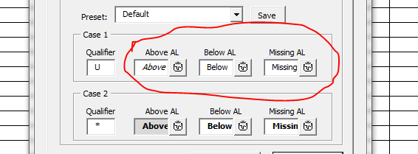

- Choose options for Bold, Italic, Underline, Strikethrough, text color and back color.
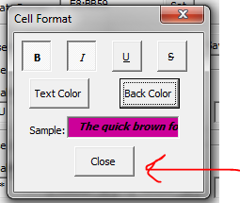
  - Press close when done.
- Once you have specified all the formatting you want then press the Format button.
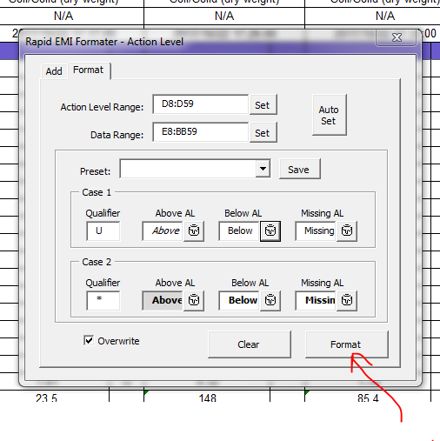

- Double check the table for accuracy. (Look for formatting).
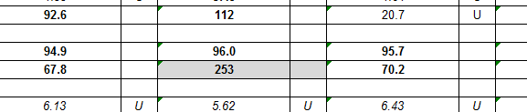

- (optional) If you want to save your format then click the save button by the preset pull down box.
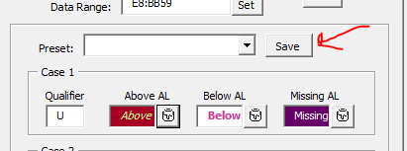

- (optional) Type in a name.
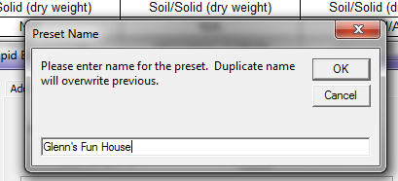

  - Note: you will have to save this the macro workbook to keep the preset for future use. (It writes the preset into a hidden table).

- (optional) Use the clear button to remove all formatting from the text boxes.
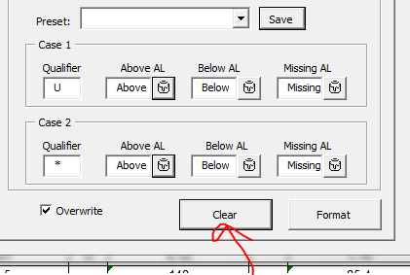

  - This is useful to remove the formatting. Press the Format button again to apply the cleared format.
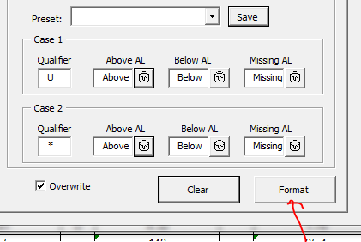

Hopefully this will get you through using this macro user interface. I am planning on updating many more things to this interface soon. If you have any question please don’t hesitate to ask.

Terrance

